SCBWI Winter Conference Intensive
Plot and Structure in Fiction
Kate Messner: Inventing the Tools We Need

www.katemessner.com

Finding the Heart of Your Story…

My book is about ____________________________________________________________________________

But underneath that, it’s really about ______________________________________________________

Whatever you do with plot, structure, and revision, ask yourself:

- Does this element/change strengthen the heart of my story?

- Does this element/change serve my story’s underlying theme?

Using Mentor Texts:
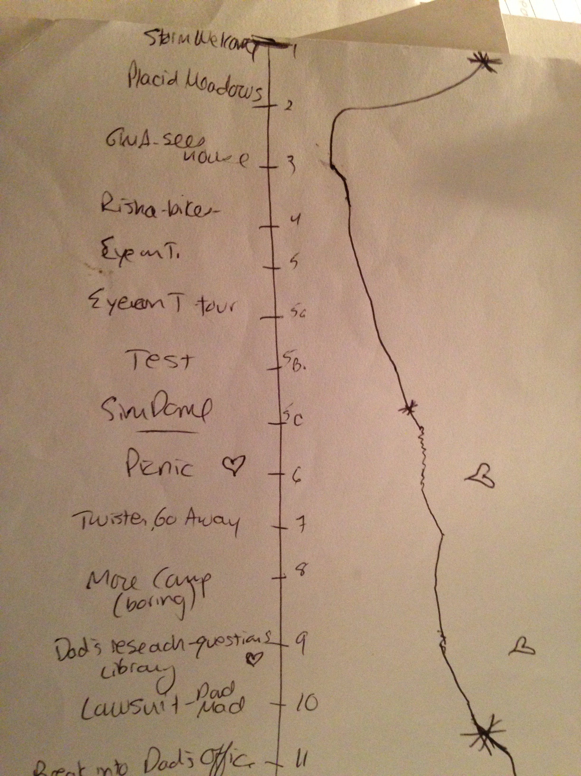
What books that you admire have the same general feel as your work-in-progress? These are your mentor texts – the stories that you might study to learn about the kinds of plot and pacing that will help you reach your goals. Try creating chapter by chapter charts that illustrate where the inciting incidents, peaks and valleys, climax, and resolutions of those mentor texts take place. Then, do the same for your current draft. What do you notice? Are there places you might tighten things up or draw things out to increase suspense?

1 2 3 4 5 6 7 8 9 10 11 12 13 14 15 16 17 18 19 20 ----

Mentor Text:

1 2 3 4 5 6 7 8 9 10 11 12 13 14 15 16 17 18 19 20 ----

My manuscript:

Planning Mysteries:

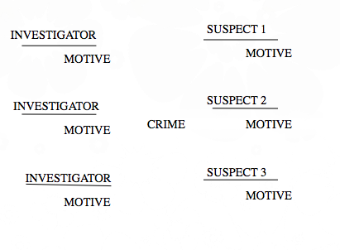
Clues?

False clues?

Futuristic Fiction – Timelines

Blend actual events in society with personal events’ in characters’ lives. Start in the present & work forward…

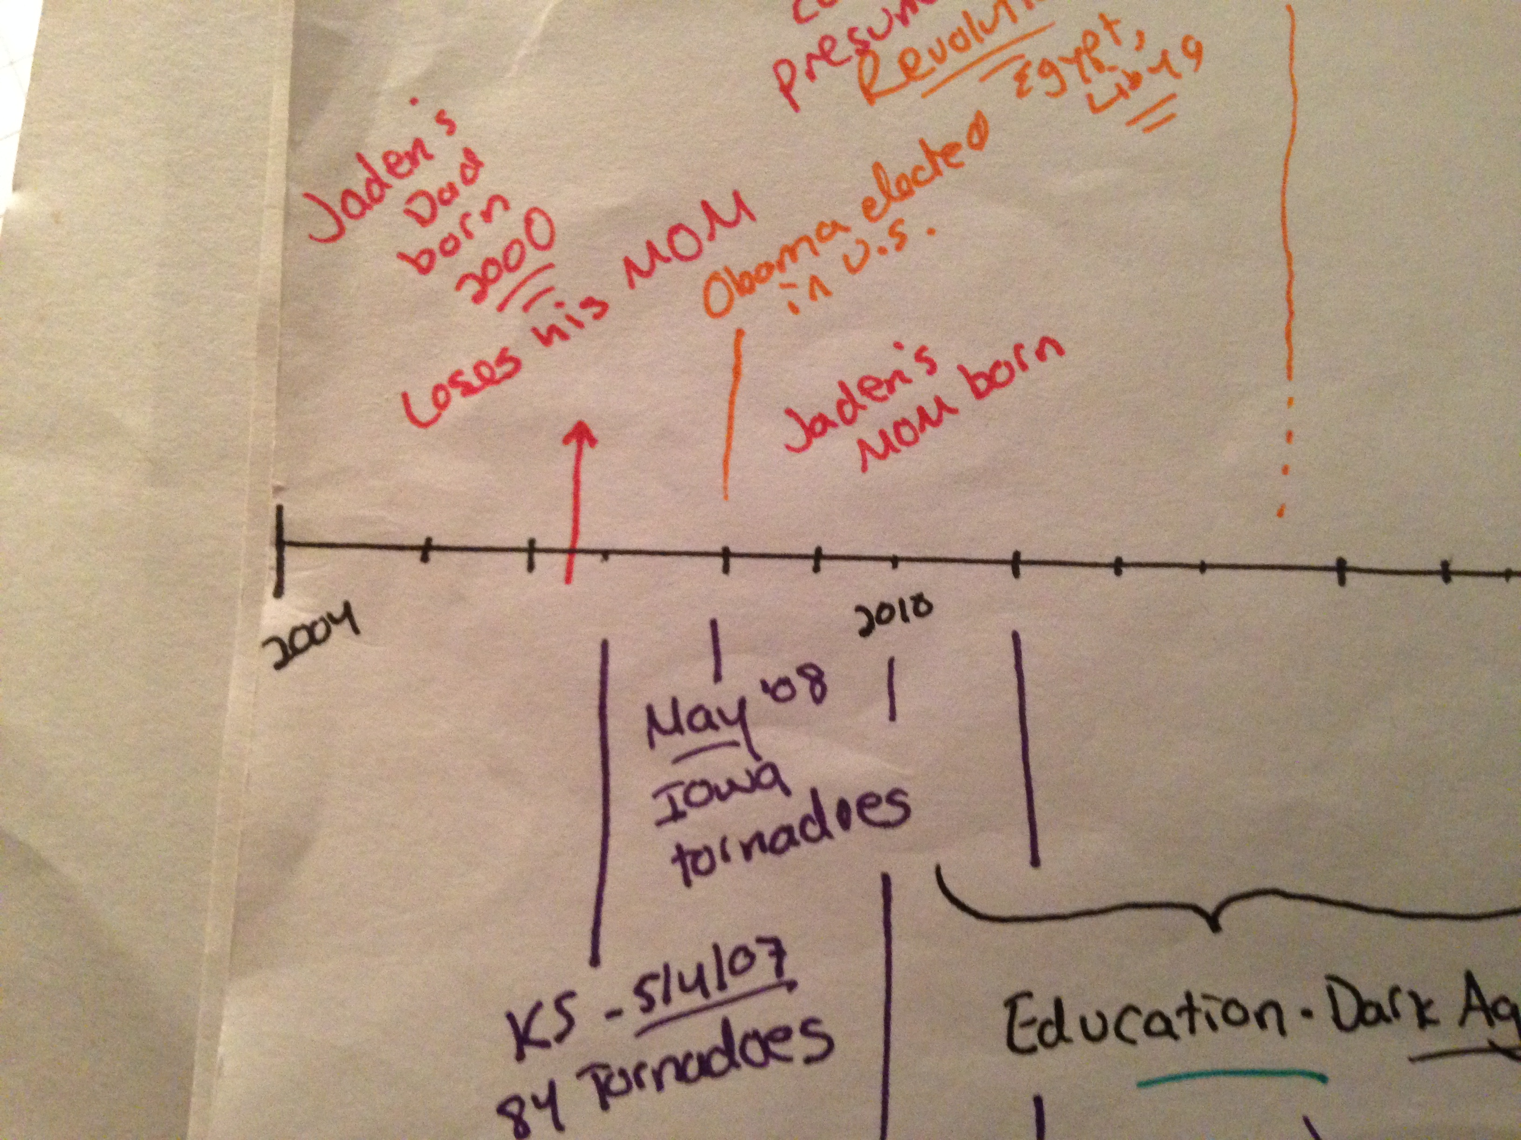

2014….. Year _______??

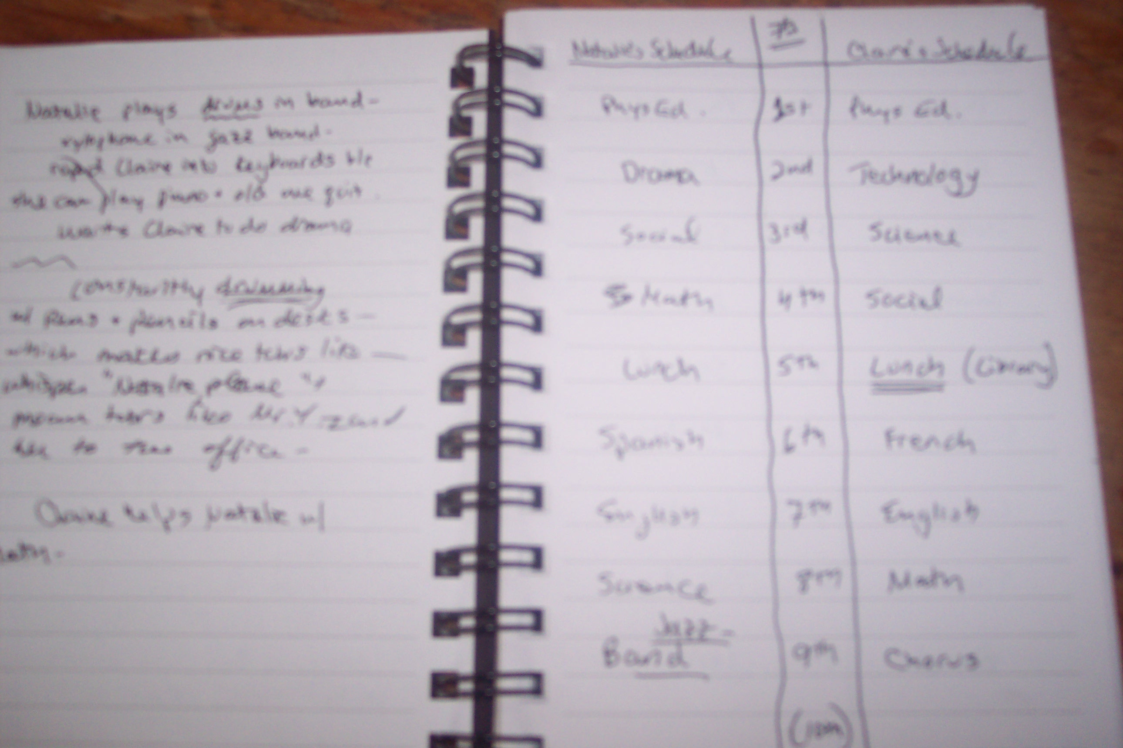
Real World Timelines:
A student’s school day

Period | Main Character’s Class | BFF’s class | Enemy/love interest’s class
Homeroom
1

2

3

4

5
6
7
8
9
After school

Plot and Setting: Are your locations varied?

Chapter | Main plot points | Settings
1
2
3
4
5
6
7
8
9
10
11
12
13
14
15
16
17
18
19
20

Character Development Chart

Chapter | What MC does | What MC says | What MC feels
1
2
3
4
5
6
7
8
9
10
11
12
13
14
15
16
17
18
19
20

